Configure a PPPoE connection on your Windows 7 system
1.) Click the "Start Icon" located on the bottom left corner of the taskbar and then click "Control Panel".

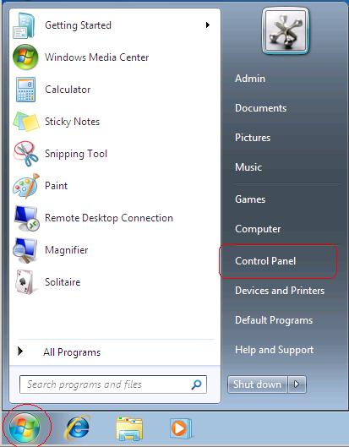

2.) Click "Network and Internet".
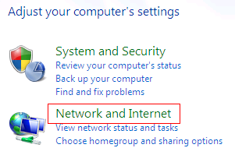

3.) Click "Network and Sharing Center".
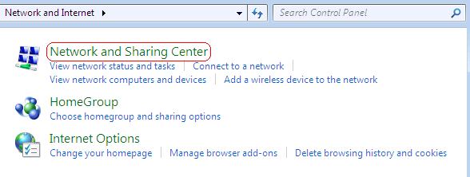

4.) Click "Set up a new connection or network".
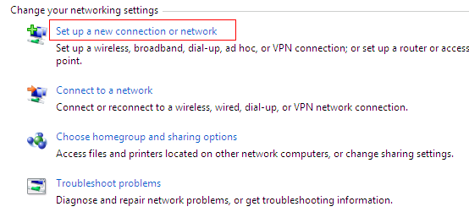
5.) The Set Up a Connection or Network window opens. Click "Connect to the Internet" and click "Next".
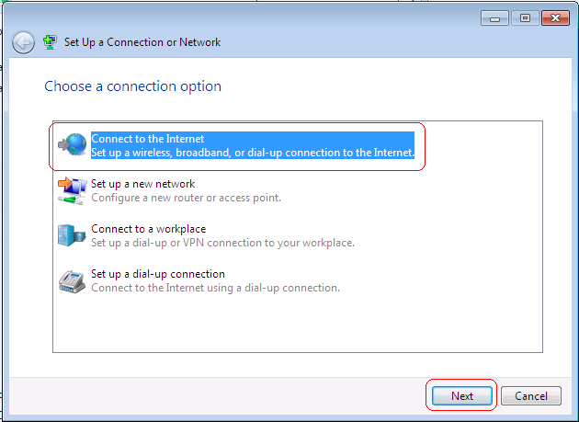

6.) If your computer is already connected to the Internet then you will see a message saying so.
Since we want to create the PPPoE Internet connection then click "Set up a new connection anyway".
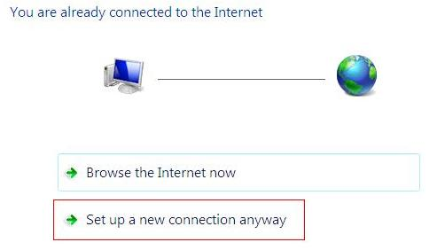

7.) The next window asks you How do you want to connect?
Choose "Broadband (PPPoE)"
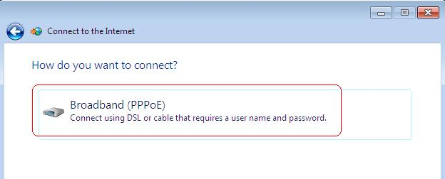

8.) In the next window, you will type in the Username and Password that your ISP provided you with.
Something like: (“@SKYNET” is necessary!)
User: ab123456@SKYNET Pass: xxxxxxxx
Under "Connection Name", you should type a name for the PPPoE connection that you can identify easily.
Click to add a check to "Allow other people to use this connection". (this setting will allow any other user on this computer use this PPPoE connection.)
Click "Connect"
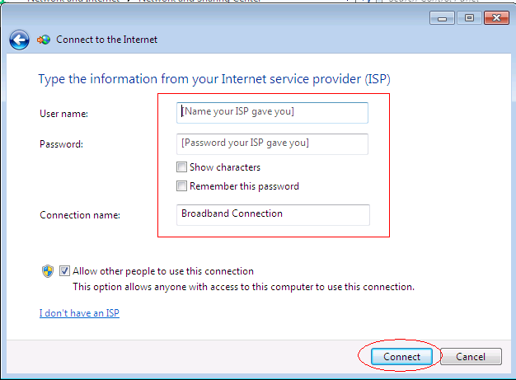

9.) An attempt to connect to your ISP will initiate.
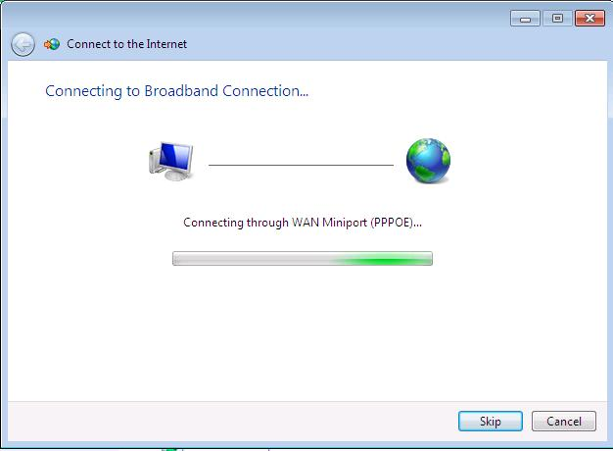

Connected

