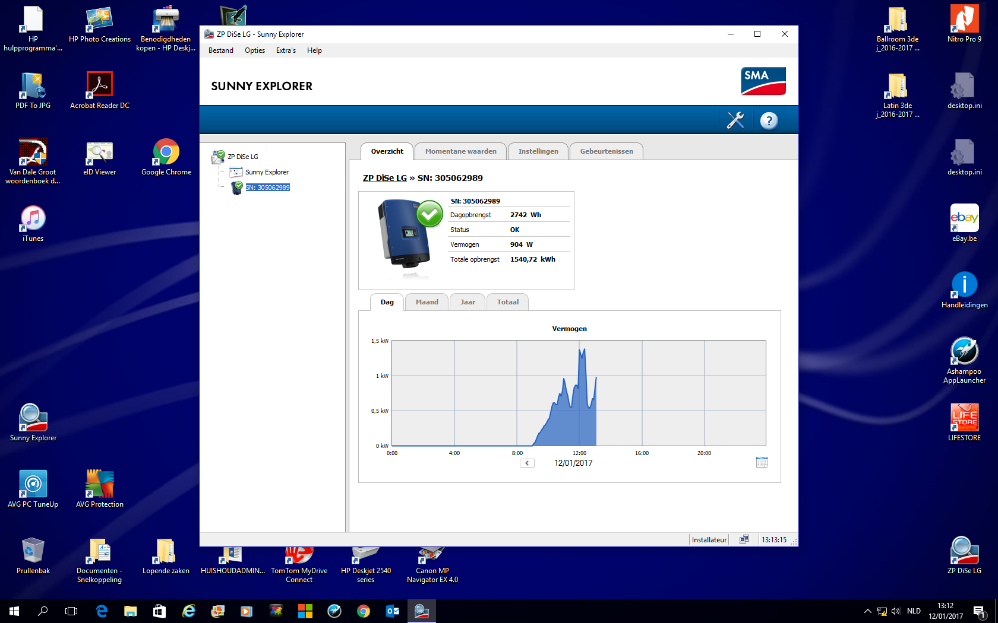Printscreen SMA_12_1_2017

